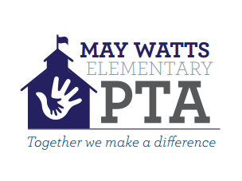 May Watts Spelling Bee 2018 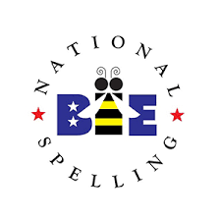

After a successful first year, May Watts is enrolled in the Scripps National Spelling Bee 2018 again.

This year, kids from Grade 3rd to 5th can enroll for the contest. Interested kids will take a 25 word Grade Level Spelling Bee (written) test after school on Wednesday, November 8th at 6:00 PM in the Gym, LMC & Multipurpose room.

The top few students from each grade will be invited to participate in the Watts Spelling Bee, to be held on Tuesday, January 30th at 6:00 PM in the GYM.
Most of the preparatory work for the Bee will need to be done by students in their own time. There are suggested word lists for each grade level. Students should begin by studying the appropriate list(s) for their grade level, and move up from there. These lists are not comprehensive, but they are a good start. Lists will be shared with the registered parents via email.
There is no registration charge for grade level competition. Students advancing to Watts Spelling Bee would need to pay $5 registration fee. Parents are invited to attend the Tuesday, January 30th contest.
If interested, please register at http://bit.ly/2wPUPLC
LAST DATE OF REGISTRATION - SEPTEMBER 29th 2017
GRADE LEVEL SPELLING BEE - NOV 8TH 2017, 6:00 PM @ GYM, LMC & MULTIPURPOSE
WATTS SPELLING BEE - JAN 30TH 2018, 6:00 PM @ GYM
Please be on time as both events will begin promptly at 6PM!
For grade level or school-wide spelling bee:
- Step One: Students should first learn the 50-100 study words for their grade level. Words are provided to the students to study when you register.
- Step Two: When your students master the initial study words for their grade level, they are ready to learn the study words for all other grade levels.
- Step Three: When your students master the study words for grade levels 1–8, they may get a head start on the next level of competition by learning the words in http://myspellit.com/spellingbee.html
Prizes and accolades
- The School Champion will get a FREE one year subscription to Britannica Online for Kids worth $69.95 and more.
- All students advancing to the Watts Spelling Bee would get a certificate of participation.
For any questions, please send an email to maywattsspellingbee@gmail.com

